Regulations:
A17

H.T No

Sreenidhi Institute of Science and Technology
(An Autonomous Institution)
Code No: 6H316 Date: 28-Nov-2018 (FN)

B.Tech II-Year I-Semester End External Examination, November - 2018 (Regular)
Mathematics for Biotechnology-II (BT)

Time: 3 Hours Max.Marks:75

Note: a) No additional answer sheets will be provided.
b) All sub-parts of a question must be answered at one place only, otherwise it will not be valued.
c) Missing data can be assumed suitably.

Part - A Max.Marks:25

Answer all QUESTIONS.

1. | Find the value of for which the system of equations  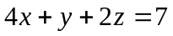 has a solution. | [3M]
2. | Using Cayley-Hamilton theorem, find the inverse of the matrix 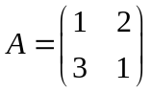. | [3M]
3. | Construct the forward difference table for the following data: | [3M]
  x | - 3 | - 2 | -1 | 0 | 1 | 2
  f(x) | - 2 | - 4 | - 4 | - 2 | 2 | 8
4. | Explain bisection method to solve 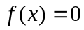. | [3M]
5. | Write the normal equations to fit a second degree curve of the form 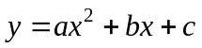 | [3M]
6. | Find an approximate value of 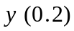 for the initial value problem 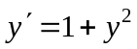,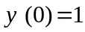  using Euler’s method with 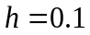. | [2M]
7. | Find the eigen values of the matrix 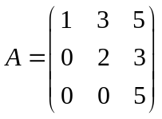 . | [2M]
8. | Write the formula of fourth order Runge-Kutta method to solve a first order differential equation. | [2M]
9. | State Simpson’s rule. | [2M]
10. | Define rank of a matrix. | [2M]
Part – B Max.Marks:50
ANSWER ANY FIVE QUESTIONS. EACH QUESTION CARRIES 10 MARKS.

11. | a) | Determine the rank of the matrix 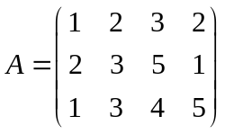. | [5M]
 | b) | Solve the system of equations by Gauss elimination method. | [5M]
12. |  | Verify Cayley-Hamilton theorem for 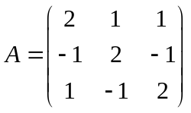 and then find 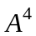. | [10M]
13. | a) | Find the Newton’s backward interpolation polynomial for the following data: | [5M]
  x | 0 | 1 | 2 | 3 | 4
  f(x) | 1 | 5 | 11 | 19 | 29
 | b) | Find the Lagrange’s interpolating polynomial for the following data: | [5M]
  x | -2 | 1 | 0 | 2
  f(x) | 3 | -3 | 1 | -1
14. |  | Find a real root of 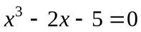 correct to two decimal places by the method of false position. | [10M]
15. | a) | Fit a straight line of the form 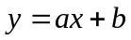 to the following data: | [5M]
  x | 1 | 2 | 3 | 4 | 5
  y | 14 | 27 | 40 | 55 | 68
 | b) | Evaluate 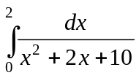 using trapezoidal rule with 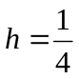. | [5M]
16. |  | Find the approximate values of 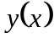 for the initial value problem 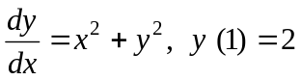 in 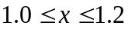 with by Runge-Kutta method of order 4. | [10M]
17. | a) | Test the following system of equations for consistency and hence solve . | [5M]
 | b) | Diagonalize the matrix 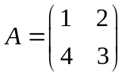 . | [5M]
18. |  | Apply Picard’s method of successive approximations to find 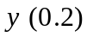 for 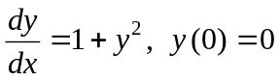. | [10M]

-- 00 -- 00 –

